École Élémentaire Collettville • Collettville Elementary School
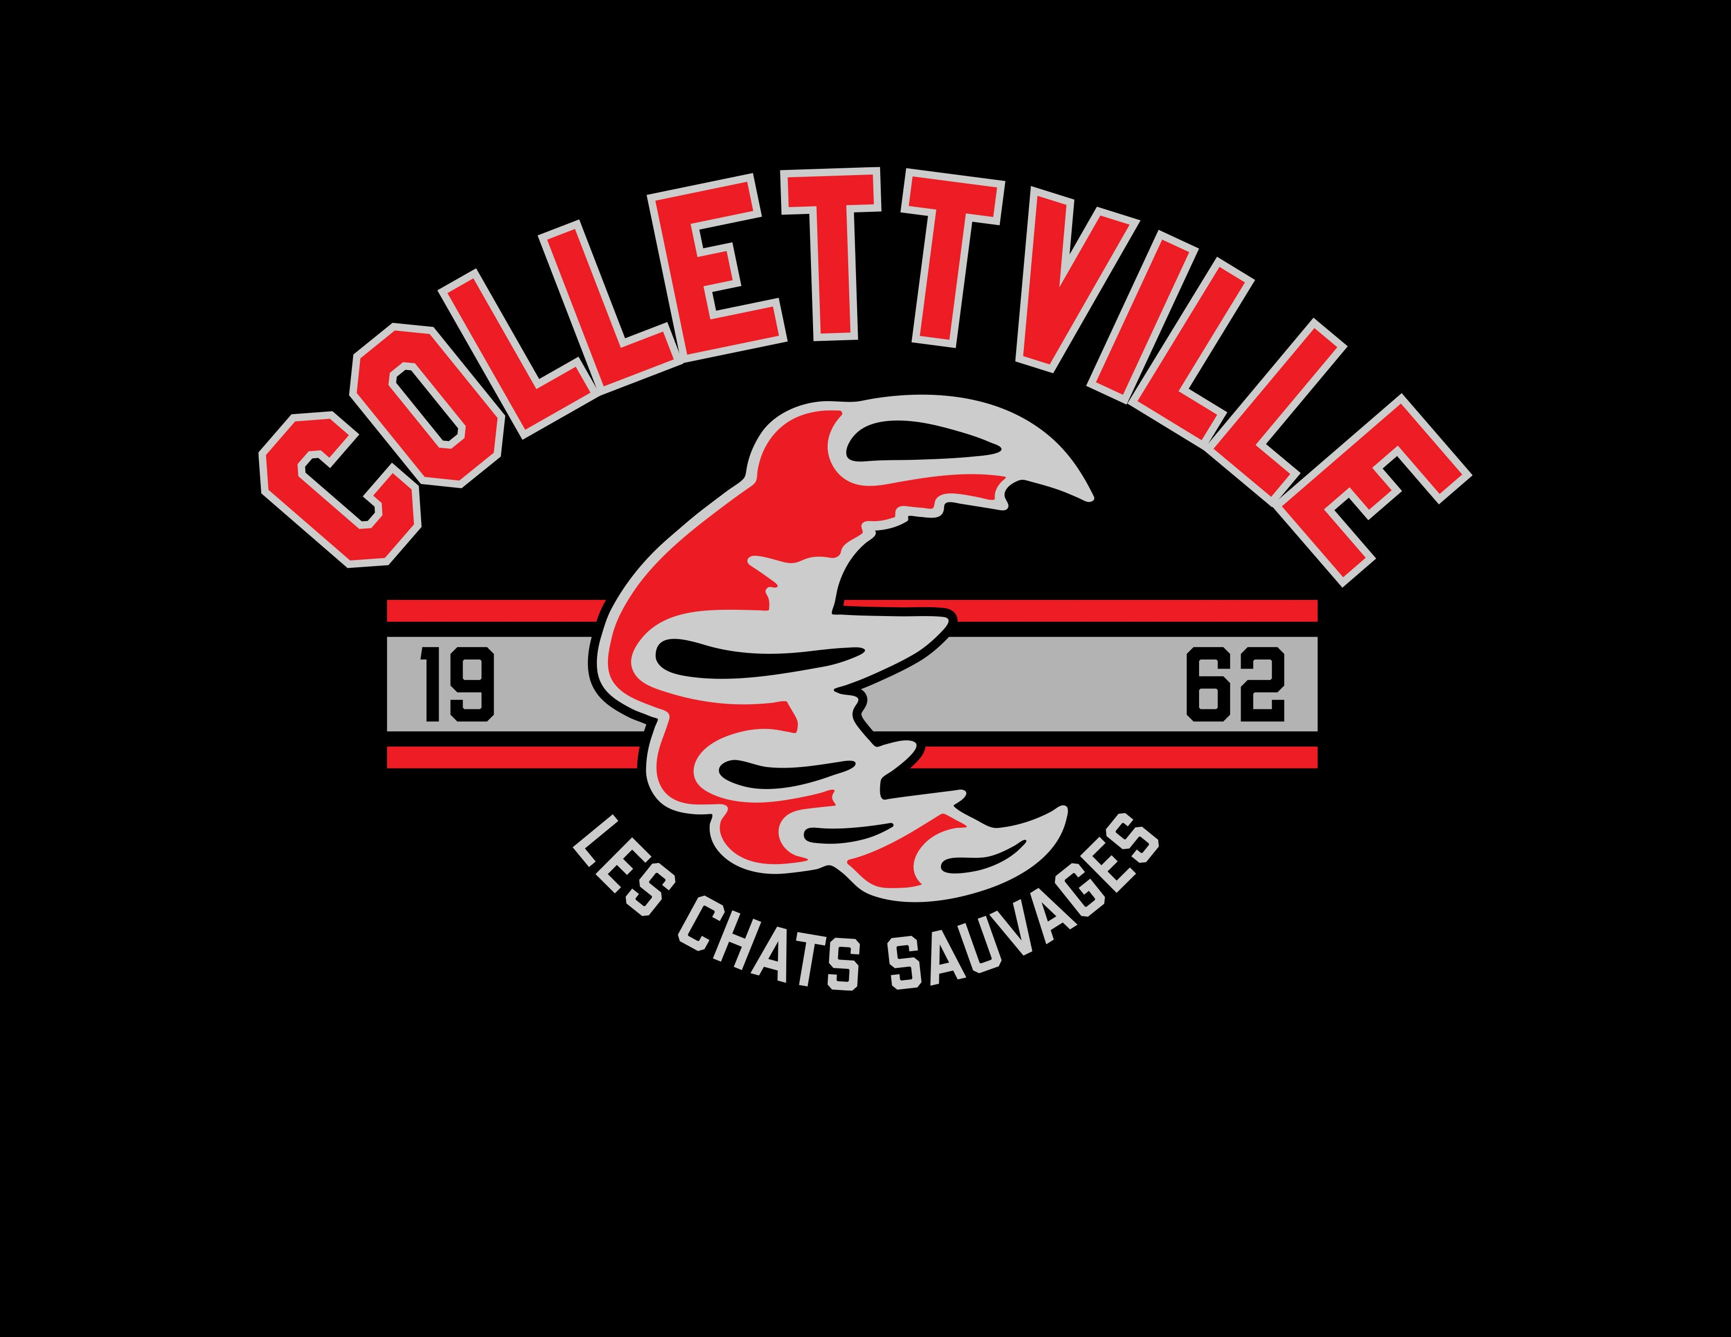
615 Lindley Creek Road, Merritt, B.C. V1K 1L4
Ph: (250) 378-2230
CVSchool@365.sd58.bc.ca
Mme Kim Parker – Directeur/Principal
E-Mail: kparker@365.sd58.bc.ca

Bonjour Collettville Parents and Guardians!

Division 1 is putting on a Purdy’s Chocolates fundraiser for the holiday season.
Orders can be made online by clicking on the link below:

https://fundraising.purdys.com/1802278-111723
You may also be required to enter the following campaign number: 73250
We appreciate your support and hope you enjoy your Purdy’s orders.

Sincerely,
Mme Tancowny
Teacher Grade 6/7 (Div 1)
Collettville Elementary School
250-378-2230

