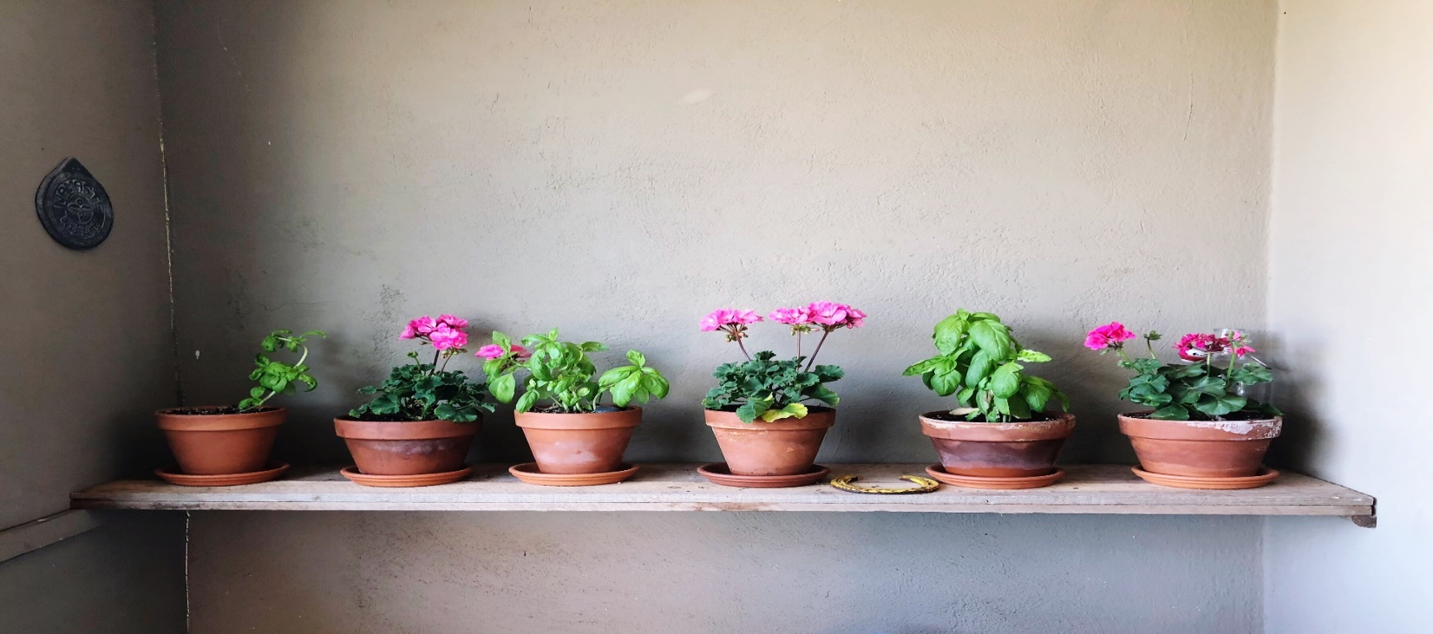
Month of March/ mois de mars 2024
Sunday Dimanche | Monday Lundi | Tuesday Mardi | Wednesday Mercredi | Thursday Jeudi | Friday Vendredi | Saturday Samedi
 |  |  |  |  | 1  Hot Dog | 2
3 | 4  Chicken & Rice Soup | 5  Boys Handball Tournament - Collettville | 6  Plain OR Cheese Slider  Promotional Videographer on Site | 7  Girls Handball Tournament - CMS  Promotional Videographer on Site | 8  Fruit Parfait  Report Cards go home | 9
10 | 11  Tomato Macaroni Soup | 12  Early Dismissal 1:55  Parent Conferences | 13  Perogies & Sausage  Early Dismissal 1:55 | 14 | 15  Cheese Quesadilla  Pajama Day! | 16
17 | 18 | 19  SPRING | 20  BREAK | 21 | 22 | 23
24 | 25 | 26  SPRING | 27  BREAK | 28 | 29  Good Friday | 30
31 | 1  Easter Monday NO SCHOOL | 2  First day back after Spring Break

